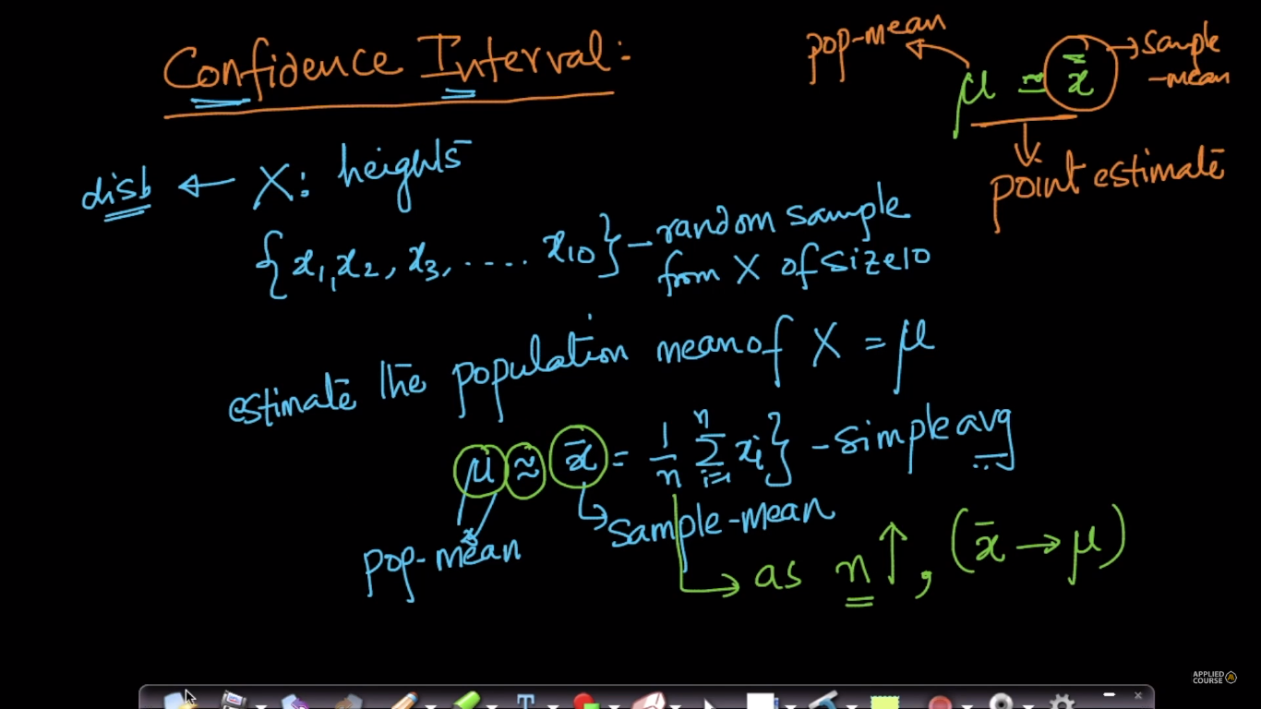

Suppose we have a large population and we want to calculate it’s mean, so what we can do is take samples from this population and calculate the mean of each sample.

The obtained sample mean is approximately equal to the population of mean.

As the sample size (n) increases, the sample mean would become more similar to mean of population.

If sample mean become exactly equal to the population mean then it’s called **Point Estimate.** But for every sample the sample mean would not be equal to population mean.

So instead of providing exact mean we can provide the interval of mean within which **95%** of samples have mean in. And this is called **Confidence Interval.**

**Note:**

Let x_bar represent the sample mean and mu represent the population mean. Now, if we repeat the sampling multiple times, each time, we get a different value of sample mean, x_bar. In 95% of the sampling experiments, mu will be between the endpoints of the C.I calculated using x_bar, but in 5% of the cases, it will not be. **95% C.I does NOT mean that mu lies in the interval with a probability of 95%.**

For example, if I know that the 95% C.I of heights of 1 yr old kids is [100cm 120cm], then, I can design my clothing so as to fit well for kids who are in the 100-120cm height range as they would fit well to the majority of 1yr kids.

